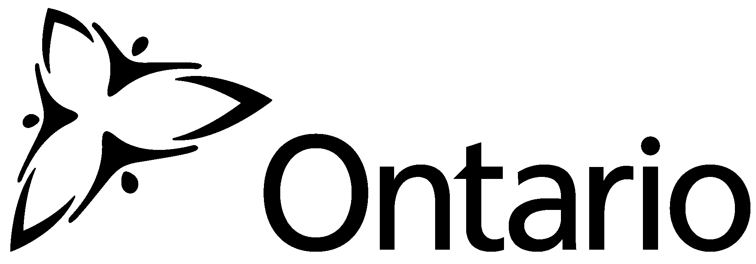 | Ministry of  the Environment |  |  |  | Laboratory Services Notification (LSN)  Schools, Private Schools and Day Nurseries  (O. Reg. 243/07)
Instructions
Please complete this form and fax/email directly to:  Ministry of the Environment  Drinking Water Programs Branch  Fax: 416 314-8716  Email: reg170_formsubmission.moe@ontario.ca |  |  |  |  |  |  |  | If you require assistance in completing the form, please call 1 866 793-2588 (toll free).  The most current version of this form is posted on the Ministry of the Environment web site at www.ene.gov.on.ca
Form Submission Information (please check one)
This is my first submission of the Laboratory Services Notification Form (LSN) to the Ministry.
Please complete sections 1, 2, 3 and 4.
I wish to notify the Ministry that I am changing licensed laboratories for my drinking-water testing.
Please complete sections 1 and 4.
I wish to notify the Ministry that I am adding another laboratory for my drinking water testing.
Please complete sections 1 and 4.
Section 1: Schools, Private Schools and Day Nurseries Information
Name of School/Day Nursery

Type
School Private School Day Nursery
Drinking Water Information System (DWIS) No.

Ministry of Education SFIS No. |  |  |  |  |  |  | Children and Youth Services Identification No.
Location of School/Day Nursery
Street No. and Name |  |  |  | Unit/Suite |  | Rural Route |  |  | Lot/Part/Block/Section |  |  | Concession/Plan
City/Town/Municipality |  |  |  |  |  | Province |  |  |  |  |  | Postal Code
Business Telephone No. (including area code)  ( ) |  |  |  |  |  | Fax No. (including area code)  ( )
Contact Information
Last Name |  | First Name |  |  |  |  |  |  |  |  | Position
Telephone No. (including area code)  ( ) ext. |  |  | Fax No. (including area code)  ( ) |  |  |  |  |  |  | Email Address
Comments

 | Schools, Private Schools and Day Nurseries (O. Reg. 243/07)
Section 2: Source of Drinking Water Supply (if known)
Name of Municipal Drinking Water System (MRDWS) which supplies school/day nursery drinking water |  |  |  |  | MRDWS No. (for ministry staff only)
Section 3: School/Day Nursery Operator Information
Legal Name of School/Day Nursery Operation (i.e. School Board)

Operator Contact Name

Street No. and Name |  | Unit/Suite | Rural Route | Lot/Part/Block/Section |  | Concession/Plan
City/Town/Municipality |  |  | Province |  |  | Postal Code
Business Telephone No. (including area code)  ( ) |  |  | Fax No. (including area code)  ( )
Email Address

 |  | Schools, Private Schools and Day Nurseries (O. Reg. 243/07)
Section 4: Identification of Licensed Laboratory and Lead Testing
O. Regulation 243/07 (Subsection 5(2)) requires the identification of any contracted licensed laboratory(s) hired to perform lead testing.
Drinking water system owners must complete and submit this form to the Ministry prior to submitting drinking water samples to your contracted licensed laboratory for testing. Once you have submitted this form, it does not have to be re-submitted unless you take your samples to a different licensed laboratory for testing. The listing of licensed laboratories can be found on the following website: http://www.ene.gov.on.ca/envision/water/sdwa/licensedlabs.htm
Failure to notify the parties in accordance with the Regulation and/or submission of false information constitutes an offence.
Your licensed laboratory can assist with completing this section of the form.
Name/Contact Information of Licensed Laboratory Performing Lead Testing
Laboratory Name |  |  |  |  |  |  | Licence Number
Street No. and Name | Unit/Suite |  |  | City/Town/Municipality |  |  | Province | Postal Code
Please specify additional testing identified in MOE (Certificate of Approval, Order or Direction)

I declare that the information provided on this form is accurate.
Prepared by (print name) |  |  | Signature |  | Date (yyyy/mm/dd) | Telephone No. (including area code)  ( )
Collection of information on this form is done in accordance with the Safe Drinking Water Act (SDWA, 2002) and its regulations. Information gathered herein, including personal information, is governed by the Freedom of Information and Protection of Privacy Act (FIPPA) and may be disclosed to other government agencies (including municipal health unit employees) pursuant to ‘Section 42’ of the FIPPA for the consistent purpose of administering any Act or program that pertains to drinking water safety. For questions and concerns, please contact the Ministry of the Environment at
1-866-793-2588.

